US Military Should Pivot Away from Fixed Bases and Focus on China Threat: Lawmaker
By Oriana Pawlyk 16 Jan 2020
https://www.military.com/daily-news/2020/01/16/us-military-should-pivot-away-fixed-bases-and-focus-china-threat-lawmaker.html?utm_source=Sailthru&utm_medium=email&utm_campaign=EBB%2001.17.20&utm_term=Editorial%20-%20Early%20Bird%20Brief
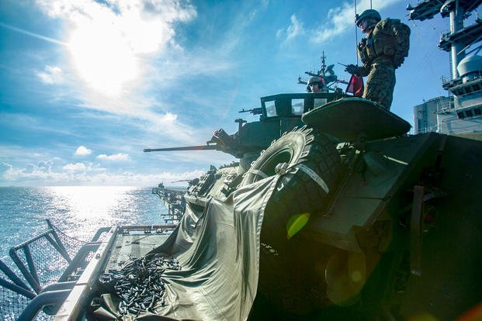
Marines with Weapons Company, Battalion Landing Team, 2nd Battalion, 5th Marines, aim a Light Armored Vehicle’s M242 Bushmaster 25 mm chain gun during gunnery training aboard the amphibious assault ship USS Wasp (LHD 1), underway in the South China Sea, Sept. 24, 2018. (U.S. Marine Corps photo/Alexis Betances)
If Iran can easily target U.S. installations in the Middle East with ballistic missiles, imagine what China could do as it continues to make long-term military and technology investments, argues one lawmaker.
Rep. Mike Gallagher, R-Wisconsin, warned an audience Wednesday at the Surface Navy Association's annual symposium outside Washington, D.C., that without adapting to threats in real time or tearing up strategic plans in favor of new ones, the National Defense Strategy -- which fixates on "great power competition" with a near-peer rival -- becomes moot.
"Like Michael Corleone, just when we think we are out of the Middle East, it keeps pulling us back in," he said, referencing the film "The Godfather." "But there is an underappreciated story playing out in the Middle East that I believe has dangerous implications for our force posture in the Pacific."
Gallagher, a former Marine, said that fixed U.S. bases are vulnerable -- sitting ducks prime for attack. The barrage of Iranian ballistic missiles that struck Iraqi air bases at Al Asad and Erbil last week is one example of the military's susceptibility to catastrophic consequences, he said.
"Given the small number of large fixed bases we have in [Indo-Pacific Command], the warning signs are flashing red," he said. "If weaker adversaries are using less sophisticated weapons to catch us off guard in [Central Command], China could do far more damage in INDOPACOM."
The National Defense Strategy prioritizes deterring adversaries by denying their use of force in the first place. Gallagher said he has ideas on how to potentially dissuade the enemy faster, especially if the U.S. can make China "worry" about a constantly shifting array of locations.
"We can accomplish this with small teams of [forward-deployed] Marines equipped with ground launch missiles of intermediate ranges, dispersed and constantly moving throughout the first island chain," he said.
Given the now-defunct Intermediate-Range Nuclear Forces (INF) Treaty, Gallagher said there is incentive to develop intermediate-range conventional missiles "as rapidly as possible."
"Some of these missiles can be loaded on mobile, fast-moving platforms such as autonomous JLTVs (Joint Light Tactical Vehicles)," he said.
"We could scatter CONEX boxes across the first island chain. Some of these boxes would have anti-ship, anti-air and perhaps even land attack missiles; others wouldn't. In the tradition of [Gen. George] Patton's 'Ghost Army,' we would leverage deception and keep the adversary on its toes and force it to account for both real and decoyed targets … which could be frequently on the move," Gallagher said.
The practice would prevent the Chinese from even attempting a successful strike, staving off any possible battle or even war, he added.
Gallagher -- who sees himself as a "China hipster," pointing to the country as a national security issue before the U.S. saw its actions as a threat -- said the Navy must look at how it works with the Marine Corps and other sister services to achieve his deterrence concepts.
The congressman said future operations are inherently tied to acquisition practices, which need overhaul, and the annual budget, which pressures officials to make tradeoffs on equipment and systems year after year.
"Congress will have to make tough choices and help the Navy-Marine Corps team rebalance investments away from systems that don't help us [accomplish deterrence, denial] in INDOPACOM in an integrated way," he said.
It's a strategy both Democrats and Republicans can agree on, he said.
"I think regardless of whoever wins the White House in 2020, this is the new consensus position within the national security community," Gallagher said. "That China's our top priority and our biggest threat, and that's going to require a lot of change."

